Logbook Week 5
February 10, 2026

On the fifth week we:
- I started working on the control system of the entire project. I chose the controller. I counted the motors we would need at each station, the type of motor, the specs we need for each one, and started shopping for them:
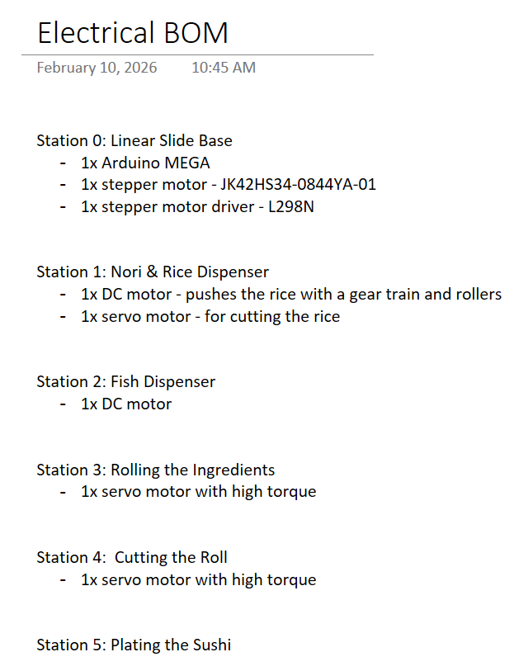
The motors determine our controller and the rest of the mechanical build, which is why they are important to focus on first. The mechanical phase will have to be structured around mounting the motors and gear trains powered by the motors.
- I also cleaned up the BOMs. I split them into three: electrical, mechanical, and miscellaneous.
- Jamie and Jacob tested the stepper motor for the linear slide with an Arduino MEGA and some code. We ran into issues with controlling it. It would just vibrate and make a loud noise and not move the way we wanted it to.

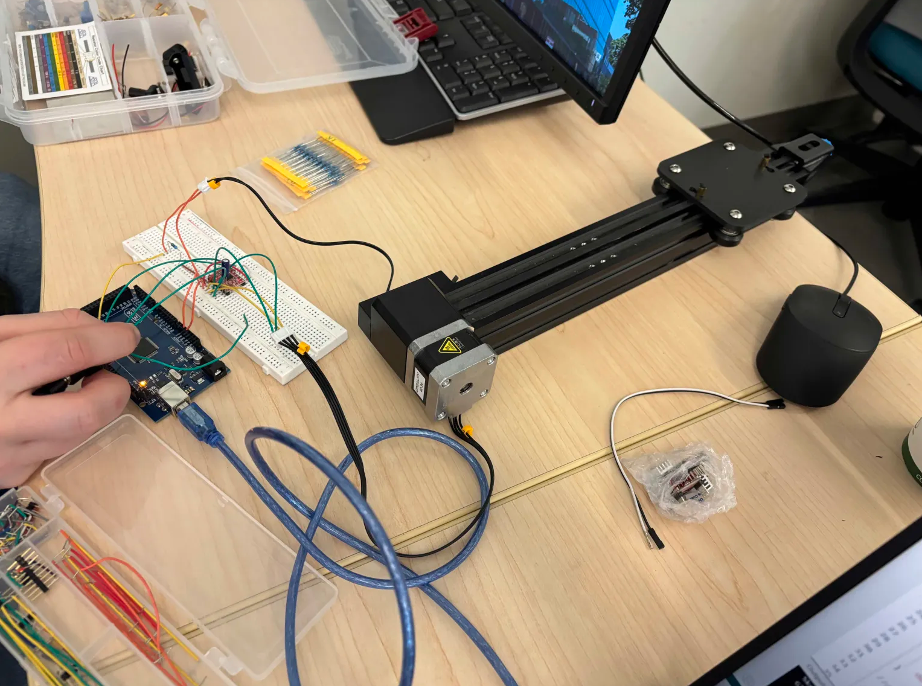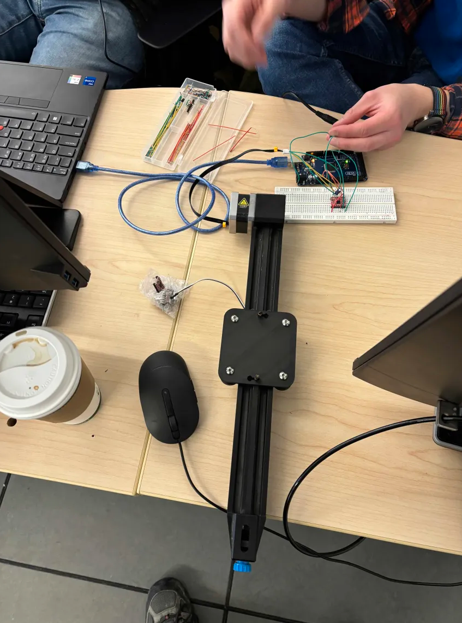
- Then we solved the issue and figured out. It just wasn’t getting enough power. We increased the voltage of the supply and it started moving correctly and smoothly. We cleaned up the code and added the limit switch to our system and now it works as we intended it to. Now all we need is a longer extrusion bar and belt for our actual system, and the linear slide base station should be mostly done, in principle.
- We also started thinking about how we will mount the ribcage roller on the platform:
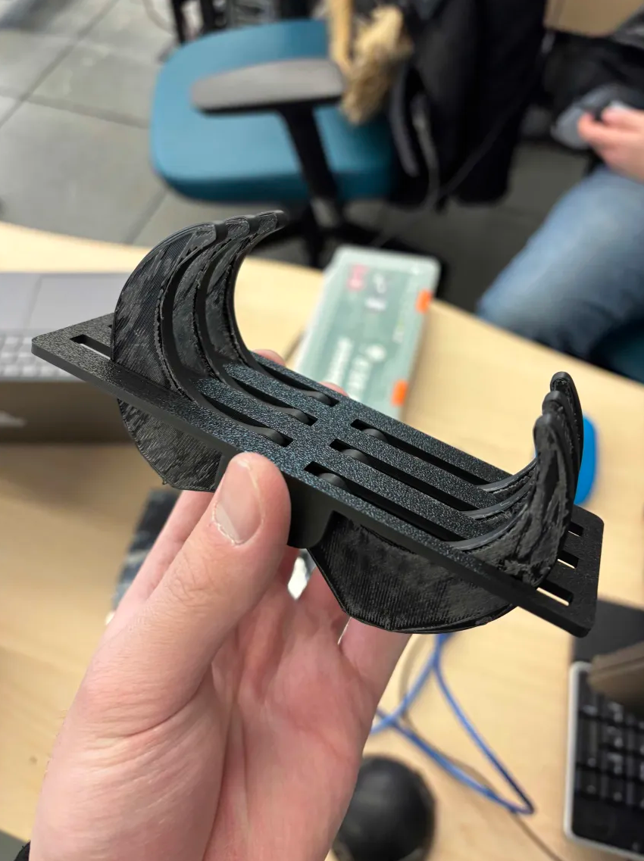
We are thinking of enlarging the platform it’s under, putting holes at each corner, and using long spacers and screws to elevate it on the platform.
- We got the bamboo mat and tested it with the platform and ran some dimensions. We determined how big we want it to be, and planned how we would cut it to be that size.
- We went with the professor to view the table with our robot again, but we had no feasible way to get the information we needed about the hole dimensions and thread size. So this task will be postponed. The professor said he will ask around if he can get that information. We are also thinking of moving the table to ETB basement already so we can start working with it and learning how to program the robot.
- As for the longer belt for the belt drive, we found a couple online but didn’t have time to finalize which one we wanted. Our options are to find a pre-crimped and cut belt and then just DIY cut and crimp it ourselves and somehow connect it to the belt we already hav eto extend it, or try to find a full spool of it that we will cut.

Things we will work on next week:
- Find out the hole thread size of the table we’re building on and the full dimensions of hole spacing (IMPORTANT for CAD progress). Perhaps there is a physical sketch or CAD from whoever made the table? (This task is continued from last week.)
- Jacob wants to start dedicating time to learning how to program our UR robot after reading week
- General continuation of work on the CAD design and BOM of substations
- General continuation of work on the motors, controller, and wiring of substations
- Specifically, I want to finalize motor part numbers and start importing them into our CAD so that we can start designing the mechanical assembly of our substations. I will also need to research and find where we can buy parts for the mechanical assembly

